Lab Report-2

Name: Mahmud

ID: 181-15-1862

Experiment: 02

Experiment Name: Tokenzation of a string using strtok() function.

Code:

#include<stdio.h>

#include<string.h>

int main()

{

char s[100]="one language are now multi-lingual with a developer team that programs in Node: js, Ruby, Java, Python, PHP, and Objective-C.";

char \*word;

word=strtok(s," :,.-");

while(word!='\0')

{

printf("%s\n",word);

word=strtok('\0'," :,.");

}

return 0;

}

Output:

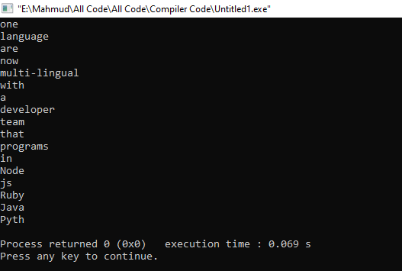

Discussion:

At first, take a string in s array.

Use Pointer for the location for string .

Then pass s string and delimiter(space :,.-)

use a while loop for the traverse s string to the null position.

print word by word of s string.

For the tract of recent read caracture use null value .